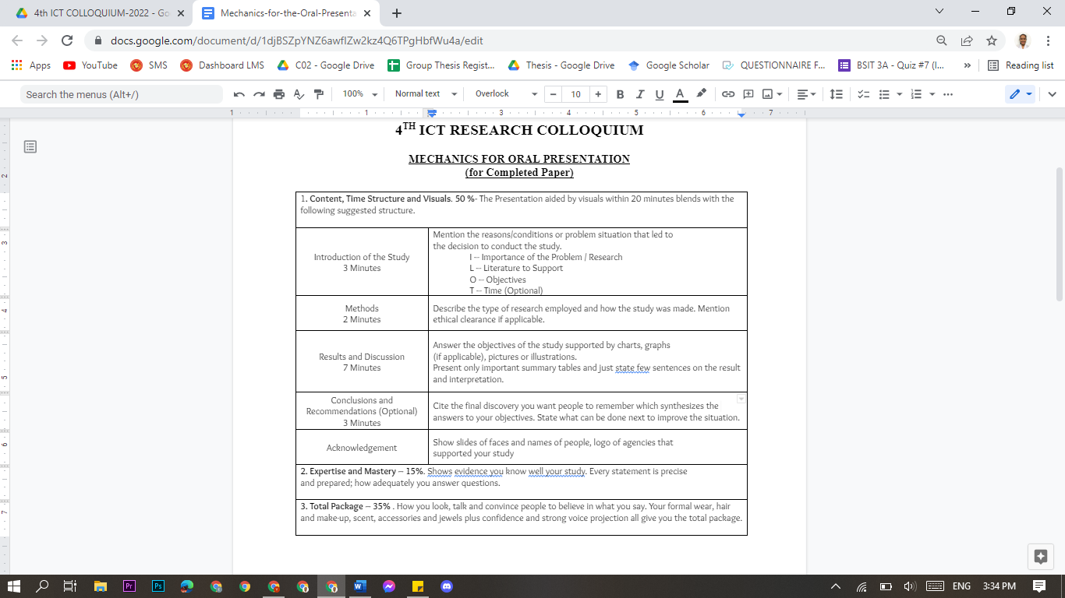

Intro of the study (3 mins)

Importance of the problem

Literature to support

Objectives

Time (optional)

Methods ( 2 mins)

Type of research employed and how the study was made, ethical implications if possible

Results and discussion (7 mins)

Can use charts pics or graphs if applicable, one summary table and few sentences for discussion and interpretation

Conclusion and Recommendation (3 mins)

Cite the final discovery to remember and synthesize the objective of the study. State the things to be done

**Introduction (3 mins)**

Abuse is defined as an act of violence and/or maltreatment towards a person or things to gain benefit. According to the Philippine Statistics Authority's (PSA) 2017 National Demographic and Health Survey, one (1) out of every four (4) Filipino women aged 15 to 49 has experienced physical, emotional, economic or sexual abuse from their husband or partner, or any family member. Over 16 million Filipino poorer women were more vulnerable to assault since they couldn't protect themselves, according to the survey. One of the Philippine laws concerning abuse is the Republic Act 9262: the Anti-Violence Against Women and their Children Act of 2004. Devised to reduce violence against women and their children (VAWC) perpetrated by their husband, intimate partners, or member of the family.

An article published by Ranada (2020) stated that it is more difficult for a victim-survivor to report their situations particularly if they are located in an area with restricted mobility and absence of public transit. Also, according to the Commission on Human Rights "Women and children who experience abuse are trapped inside their homes with their abusers, and have nowhere to go. Most of these women are not able to seek help due to fear of being overheard by their abusive partners or stopped from leaving home". The question lies on what the other available platforms where victims/witnesses can place their complaints in a confidential environment are. Although there are campaigns about abuse protections and hotlines to raise awareness before and during the pandemic, a lot of people are still unmindful of it. The following problems gave the researchers an idea of what the study could do: How knowledgeable are the victims regarding the appropriate emergency hotlines; How difficult is it for the victim to reach out and report their difficult or abused situation to the emergency hotlines and office’s desks; What to do when the victim is in that difficult or dangerous situation; How to know what and who are the possible causes of abuse in the area; How to file for an initial abuse report of an offender or abuser without actually calling for the authorities.

Having and creating an Awareness Module found in the application iJuanaHelpMo educates victims that can help to know their own rights, what resources they can find, and support that is applicable to any Filipinos regarding violence and abuse they experience inside their homes. In this application module, victims can read related laws and rights related to Violence Against Women and Children. They can educate themselves as it serves a series of references that is linked to their current state (Balahadia & Mortel, 2020).

With this, the researchers decided to propose a study entitled ***#31b: A 117 Emergency Communication Platform for Abuse Report in a Mobile Application***, an application that would be able to help decrease the escalating rate of domestic abuse and variety of physical, mental, economic and sexual abuse that is happening in the Philippines. The proposed study aims to establish an idea of a free communication platform for the victims and witnesses of abuse that is user-friendly, with better assistance, immediate response, and with the help and support from the local authorities and social services.